Grafana

Version: 1.0.0

Date Submitted: 04/12/2024.

Prepared for OSGS

Review and Revision History

|  |  |  |  |
| --- | --- | --- | --- |
| Date | Version | Revised By | Reason for Revision |
| *04/12/2024* | 1.0.0 | *Srilekha P* | Initial Document |

Contents

1 To Customize a Dashboard 4

1.1 To create a dashboard 4

1.2 To import a dashboard 7

1.3 To copy a dashboard 7

1.4 Related Documents 8

2 To Customize Panels 9

2.1 Move a Panel 9

2.2 Resize a Panel 9

2.3 Format a Panel 9

2.4 Adding Background Colors and Color Grading 10

2.4.1 Panel Options 10

2.4.2 Example: Customizing a Stat panel 12

2.4.3 Example: Customizing a Bar Chart panel 13

2.5 Copy and paste of panel 13

2.6 Related Documents 14

3 Variables 15

3.1 To add a Variable 15

3.2 Using Variables inside the panels 15

3.2.1 Example: Setting Up Variables for Azure Monitor 16

3.2.2 Using Variables in Panel Query 18

4.1 Related Documents 19

# To Customize a Dashboard

## To create a dashboard

This section contains detailed instructions to create dashboards.

1. **Navigate to Dashboards**: Click on the "Dashboards" option in the main menu.
2. **Create a New Dashboard**: Click on "New" and select "New Dashboard".
3. **Add a Visualization**: On the empty dashboard, click "+ Add visualization".

1. **Select Data Source**: Choose one of your existing data sources or configure a new one.

1. The **Edit panel** view opens with your data source selected. You can change the panel data source later using the drop-down in the **Query** tab of the panel editor if needed.
2. **Write a Query**: Construct a query in the query language of your data source.
3. **Select Visualization Type**: Choose a visualization type from the list.
4. **Configure Panel Options**: Enter a title and description for your panel, and adjust settings as needed. In the visualization list, select a visualization type.

1. **Save Dashboard**: Click "Save dashboard" and provide a title and description for your dashboard.
2. Alternatively, click **Back to dashboard** if you want to see your changes applied to the dashboard first. Then click **Save dashboard** when you’re ready.
3. To add more panels to the dashboard, click **Back to dashboard**. Then click **Add** in the dashboard header and select **Visualization** in the drop-down.

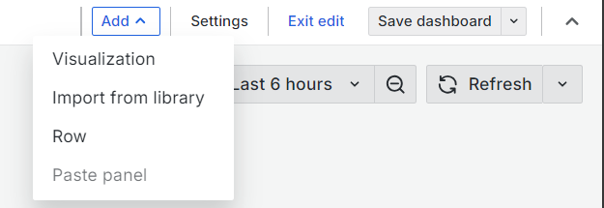

1. When you add additional panels to the dashboard, you’re taken straight to the **Edit panel** view.
2. When you’ve saved all the changes you want to make to the dashboard, click **Exit edit**.
3. Now, when you want to make more changes to the saved dashboard, click **Edit** in the top-right corner.

## To import a dashboard

1. Click **Dashboards** in the primary menu.
2. Click **New** and select **Import** in the drop-down menu.

1. Perform one of the following steps:
   * Upload a dashboard JSON file.
   * Paste a Grafana.com dashboard URL or ID into the field provided.
   * Paste dashboard JSON text directly into the text area.
2. (Optional) Change the dashboard name, folder, or UID, and specify metric prefixes, if the dashboard uses any.
3. Select a data source, if required.
4. Click **Import**.

## To copy a dashboard

1. Click **Dashboards** in the main menu.
2. Open the dashboard you want to copy.
3. Click **Edit** in top-right corner.
4. Click the **Save dashboard** drop-down and select **Save as copy**.
5. (Optional) Specify the name, folder, description, and whether to copy the original dashboard tags for the copied dashboard.

By default, the copied dashboard has the same name as the original dashboard with the word “Copy” appended and is in the same folder.

1. Click **Save**.

## Related Documents

Table 1‑1: Related Documents

| Document Name | Document Location |
| --- | --- |
| Dashboard Creation | [Create a dashboard | Grafana documentation](https://grafana.com/docs/grafana/latest/dashboards/build-dashboards/create-dashboard/) |
| Import Dashboard | [Import dashboards | Grafana documentation](https://grafana.com/docs/grafana/latest/dashboards/build-dashboards/import-dashboards/) |
|  |  |
|  |  |

# To Customize Panels

This section contains detailed instructions to customize panels.

## Move a Panel

You can place a panel on a dashboard in any location.

1. Click **Dashboards** in the main menu.
2. Navigate to the dashboard you want to work on.
3. Click **Edit** in the top-right corner.
4. Click the panel title and drag the panel to the new location.
5. Click **Save dashboard**.
6. (Optional) Enter a description of the changes you’ve made.
7. Click **Save**.
8. Click **Exit edit**.

## Resize a Panel

You can size a dashboard panel to suits your needs.

1. Click **Dashboards** in the main menu.
2. Navigate to the dashboard you want to work on.
3. Click **Edit** in the top-right corner.
4. To adjust the size of the panel, click and drag the lower-right corner of the panel.
5. Click **Save dashboard**.
6. (Optional) Enter a description of the changes you’ve made.
7. Click **Save**.
8. Click **Exit edit**.

## Format a Panel

1. **Open Panel Editor**:
   * Click on the panel title and select "Edit" to open the panel editor.
2. **General Settings**:
   * **Title**: Enter a title for your panel.
   * **Description**: Add a description to provide context or instructions for the panel.
   * **Transparent Background**: Toggle this switch to make the panel background transparent, matching the dashboard background.
3. **Visualization Options**:
   * **Visualization Type**: Select the type of visualization (e.g., Graph, Table, Stat).
   * **Data Source**: Choose the data source for your panel.
   * **Query**: Write the query to fetch the data you want to visualize.

## Adding Background Colors and Color Grading

1. **Edit the Panel**:
   * Click on the panel title and select "Edit" to open the panel editor.
2. **Navigate to the Display Options**:
   * For Stat panels, go to the "Display" tab.
   * For Bar Chart panels, go to the "Field" tab.
3. **Set Background Color**:
   * **Stat Panel**: In the "Display" tab, look for the "Background" section. You can choose a solid color or set a gradient.
   * **Bar Chart Panel**: In the "Field" tab, you can set the background color for the entire panel or individual bars.
4. **Set Text Color**:
   * **Stat Panel**: In the "Display" tab, you can set the text color under the "Text" section.
   * **Bar Chart Panel**: In the "Field" tab, you can set the text color for labels and values.

### Panel Options

1. **Color Scheme**:
   * **Standard Options**: In the panel editor, go to the "Standard options" section.
   * **Color Scheme**: Choose a color scheme that fits your data. You can select from predefined color schemes or customize your own.

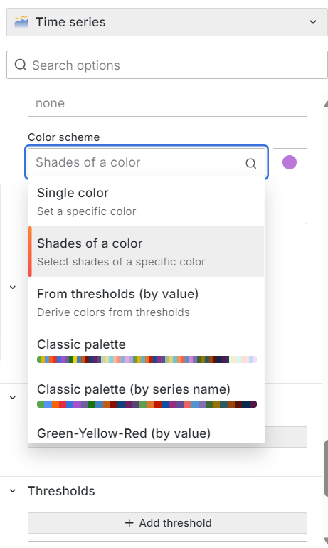

1. **Thresholds**:
   * **Set Thresholds**: Define thresholds to apply color grading based on data values. For example, you can set thresholds to change colors when values exceed certain limits.
   * **Threshold Colors**: Assign colors to different threshold ranges. This helps in visually distinguishing between different data ranges.

1. **Field Overrides**:
   * **Add Override**: In the "Field overrides" section, click "Add override" to customize specific fields.
   * **Override Properties**: Select properties like color, unit, and display name to override the default settings for specific fields.
2. **Background Color for Panels**:
   * **Panel Background**: To add a background color to the entire panel, you can use custom CSS or adjust the panel settings if the option is available in your Grafana version.

### Example: Customizing a Stat panel

1. **Edit Stat Panel**:
   * Click on the panel title and select "Edit".
2. **Set Background Color**:
   * Go to the "Display" tab.
   * Under "Background", select "Solid" or "Gradient".
   * Choose your desired colors.
3. **Set Text Color**:
   * In the "Text" section, set the color for the text.
4. **Apply and Save**:
   * Click "Apply" to save your changes and see the updated panel.

### Example: Customizing a Bar Chart panel

1. **Edit Bar Chart Panel**:
   * Click on the panel title and select "Edit".
2. **Set Bar Colors**:
   * Go to the "Field" tab.
   * Under "Color", choose "Solid" or "Gradient".
   * Set the colors for the bars.
3. **Set Background Color**:
   * In the "Field" tab, set the background color for the panel.
4. **Set Text Color**:
   * In the "Field" tab, set the text color for labels and values.
5. **Apply and Save**:
   * Click "Apply" to save your changes and see the updated panel.

## Copy and paste of panel

1. **Open the Dashboard**:
   * Navigate to the dashboard containing the panel you want to copy.
2. **Access Panel Menu**:
   * Click on the panel title to open the panel menu.
   * Select "More..." (three dots) to expand the options.
3. **Copy Panel**:
   * Click on "Copy" to copy the panel configuration to your clipboard.
4. **Open Target Dashboard**:
   * Navigate to the dashboard where you want to paste the panel.
5. **Add New Panel**:
   * Click on "Add panel" and select "Add new panel".
6. **Paste Panel**:
   * In the new panel editor, click on the "Panel JSON" option.
   * Paste the copied JSON configuration into the editor.
   * Click "Apply" to add the panel to your dashboard.

## Related Documents

Table 2‑1: Related Documents

| Document Name | Document Location |
| --- | --- |
| Panel Options | [Configure panel options | Grafana documentation](https://grafana.com/docs/grafana/latest/panels-visualizations/configure-panel-options/) |
| Move and Resize a Panel | [Create a dashboard | Grafana documentation](https://grafana.com/docs/grafana/latest/dashboards/build-dashboards/create-dashboard/) |
| Standard Options | [Configure standard options | Grafana documentation](https://grafana.com/docs/grafana/latest/panels-visualizations/configure-standard-options/) |
|  |  |

# Variables

## To add a Variable

1. **Open Dashboard Settings**:
   * Click on the gear icon at the top of the dashboard and select "Variables".
2. **Add a New Variable**:
   * Click "Add variable".
3. **Configure the Variable**:
   * **Name**: Enter a name for the variable (e.g., subscription, rg, resource).
   * **Type**: Select "Query" from the variable type dropdown.
4. **Set the Data Source**:
   * Choose the data source that you want to query (e.g., Azure Monitor, Prometheus).
5. **Write the Query**:
   * **Subscription**: For Azure Monitor, you might use a query like AzureMonitorSubscriptions().
   * **Resource Group**: Use a query like AzureMonitorResourceGroups(subscription='$subscription').
   * **Resource**: Use a query like AzureMonitorResources(subscription='$subscription', resourceGroup='$rg').
6. **Additional Options**:
   * **Label**: Optionally, provide a label for the variable.
   * **Refresh**: Choose when the variable should update (e.g., "On Dashboard Load").
   * **Sort**: Select the sort order for the variable values.
7. **Save the Variable**:
   * Click "Save" to add the variable to your dashboard.

## Using Variables inside the panels

1. **Edit the Panel**:
   * Click on the panel title and select "Edit" to open the panel editor.
2. **Use Variables in Queries**:
   * In the query editor, use the variables by referencing them with a $ sign. For example:
   * SELECT * FROM metrics WHERE subscription = '$subscription' AND resourceGroup = '$rg' AND resource = '$resource'
3. **Dynamic Queries**:
   * The panel will dynamically update based on the selected values of the variables.
4. **Apply Filters**:
   * Use the variable dropdowns at the top of the dashboard to filter the data displayed in the panels.

### Example: Setting Up Variables for Azure Monitor

1. **Subscription Variable**:
   * **Name**: subscription
   * **Type**: Query
   * **Data Source**: Azure Monitor
   * **Query**: AzureMonitorSubscriptions()

1. **Resource Group Variable**:
   * **Name**: rg
   * **Type**: Query
   * **Data Source**: Azure Monitor
   * **Query**: AzureMonitorResourceGroups(subscription='$subscription')

1. **Resource Variable**:
   * **Name**: resource
   * **Type**: Query
   * **Data Source**: Azure Monitor
   * **Query**: AzureMonitorResources(subscription='$subscription', resourceGroup='$rg')

### Using Variables in Panel Query

1. **Edit the Panel**:
   * Open the panel editor.
2. **Write the Query**:
   * Use the variables in your query. For example, in a SQL data source:
   * SELECT * FROM metrics WHERE subscription = '$subscription' AND resourceGroup = '$rg' AND resource = '$resource'
3. **Apply and Save**:
   * Click "Apply" to save the changes and see the panel update based on the selected variable values.

**Additional Tips:**

* **Chained Variables**: You can create chained variables where one variable depends on the value of another.
* **Regex Filtering**: Use regex in the variable query to filter specific values.
* **Multi-Value and Include All**: Enable multi-value or include all options for variables to allow multiple selections or an "All" option.

## Related Documents

Table 3‑1: Related Documents

| Document Name | Document Location |
| --- | --- |
| Add Variables | [Add variables | Grafana documentation](https://grafana.com/docs/grafana/latest/dashboards/variables/add-template-variables/) |
| Variables | [Variables | Grafana documentation](https://grafana.com/docs/grafana/latest/dashboards/variables/) |
| Variable Syntax | [Variable syntax | Grafana documentation](https://grafana.com/docs/grafana/latest/dashboards/variables/variable-syntax/) |
|  |  |