Grafana

Version: 1.0.0

Date Submitted: 20/08/2024

Prepared for OSGS

Review and Revision History

|  |  |  |  |
| --- | --- | --- | --- |
| Date | Version | Revised By | Reason for Revision |
| *20/08/2024* | 1.0.0 | *Varsha V* | Initial Document |

Contents

1 Sharing Dashboards 4

1.1 Direct Link 4

1.2 Snapshot 4

1.3 JSON 6

1.4 PDF 7

1.5 Comparison 8

1.6 Related Documents 8

2 Sharing Panels 9

2.1 Direct Link 9

2.2 Snapshot 10

2.3 Embedding 11

2.4 Comparison 13

2.5 Related Documents 13

Appendix A – Links 14

Steps to Update the doc 15

# Sharing Dashboards

## Direct Link

* User must have an authorized viewer permission to see an image rendered by direct link.
* Steps:

1. Click **Dashboards** in the left-side menu.
2. Click the dashboard you want to share.
3. Click the **Share** button at the top right of the screen. The share dialog opens and shows the Link tab.
4. The **Link** tab shows the current time range, template variables, and the default theme. You can also share a shortened URL.
5. Click **Copy**. This action copies the default or the shortened URL to the clipboard.
6. Send the copied URL to a Grafana user with authorization to view the link.

## Snapshot

* A dashboard snapshot shares an interactive dashboard publicly. Grafana strips sensitive data such as queries (metric, template and annotation) and panel links, leaving only the visible metric data and series names embedded in the dashboard
* When you share a panel or dashboard as a snapshot, a snapshot (which is a panel or dashboard at the moment you take the snapshot) is publicly available on the web. Anyone with a link to it can access it. Because snapshots do not require any authorization to view, Grafana removes information related to the account it came from, as well as any sensitive data from the snapshot.
* You can set an expiration time if you want the snapshot removed after a certain time period.
* Steps to create:

1. Click the **Snapshot** tab.
2. Click **Publish to snapshots.raintank.io** or **Publish Snapshot**.

Grafana generates a link of the snapshot.

1. Copy the snapshot link, and share it either within your organization or publicly on the web.

* Steps to Delete a Snapshot:

1. In the primary menu, click **Dashboards**.
2. Click **Snapshots** to go to the snapshots management page.
3. Click the red **x** next to the snapshot URL that you want to delete.
4. The snapshot is immediately deleted. You may need to clear your browser cache or use a private or incognito browser to confirm this.

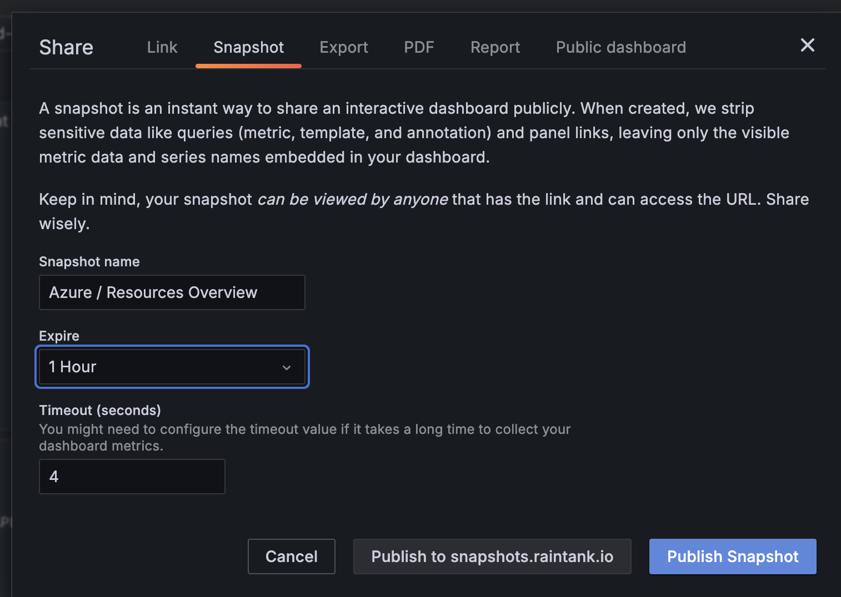

## JSON

* The dashboard export action creates a Grafana JSON file that contains everything you need, including layout, variables, styles, data sources, queries, and so on, so that you can later import the dashboard.
* Steps:

1. Click **Dashboards** in the main menu.
2. Open the dashboard you want to export.
3. Click the **Share** icon in the top navigation bar.
4. Click **Export**.

If you’re exporting the dashboard to use in another instance, with different data source UIDs, enable the **Export for sharing externally** switch.

1. Click **Save to file**. Grafana downloads a JSON file to your local machine.

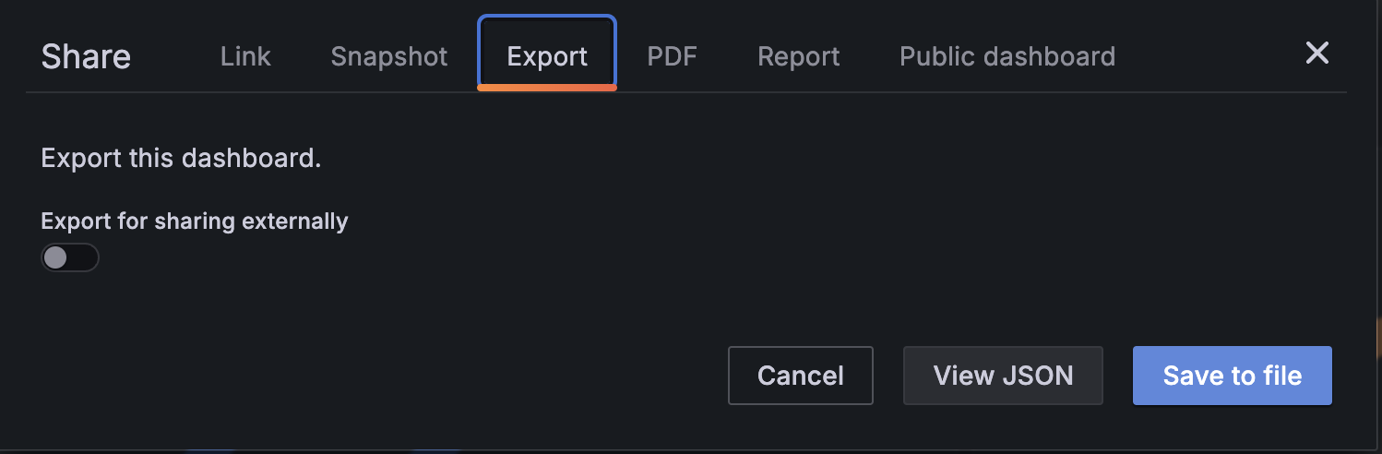

## PDF

* Prerequisite: Install “Grafana Image Renderer” plugin.
* Install Image Renderer using configuration yaml file (which is used while setting up Grafana).

**imageRenderer:  
deploymentStrategy: {}  
# Enable the image-renderer deployment & service  
enabled: true**

1. Click **Dashboards** in the left-side menu.
2. Click the dashboard you want to share.
3. Click the **Share** button at the top right of the screen.
4. On the PDF tab, select a layout option for the exported dashboard: **Portrait** or **Landscape**.
5. Click **Save as PDF** to render the dashboard as a PDF file.

Grafana opens the PDF file in a new window or browser tab.

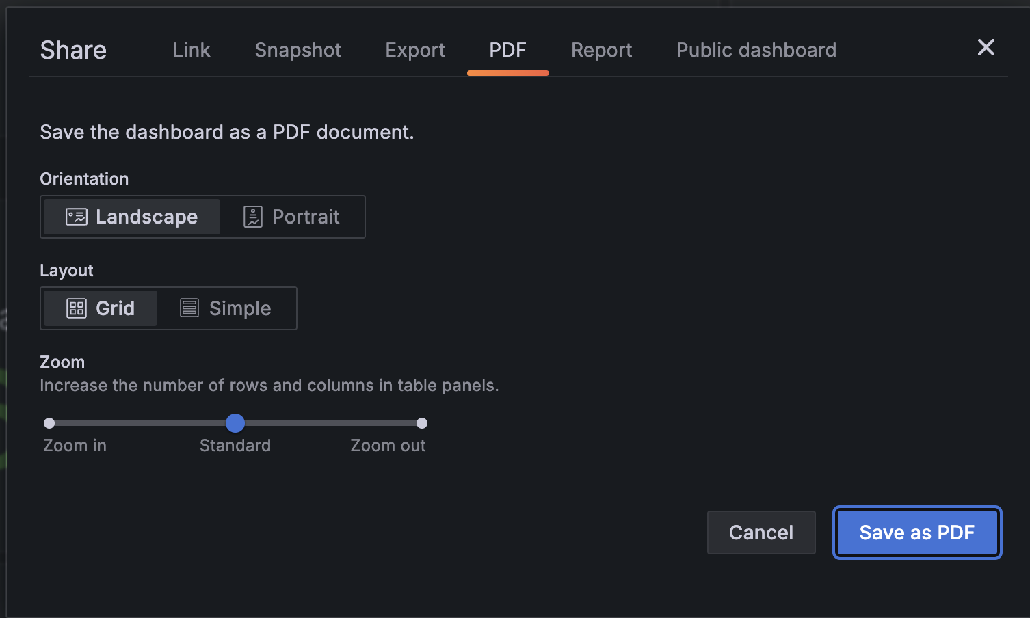

## Comparison

|  |  |  |  |  |  |
| --- | --- | --- | --- | --- | --- |
|  | Direct Link | Snapshot | JSON | PDF |  |
| Access | Any user with the link | Anyone with the link | NA | NA |  |
| Login required? | Yes | No | NA | No |  |
| Real Time Data | Yes | No | NA | No |  |
|  |  |  |  |  |  |

## Related Documents

Table 1‑1: Related Documents

| Document Name | Document Location |
| --- | --- |
| Share Dashboards and Panels | https://grafana.com/docs/grafana/latest/dashboards/share-dashboards-panels/#share-dashboards-and-panels |
| Grafana Image renderer plugin install | https://urldefense.com/v3/__https://github.com/grafana/helm-charts/blob/79a0101296b0065b18987321b3047b8c94bc1a33/charts/grafana/values.yaml*L1150C1-L1150C5__;Iw!!IqUcNYopQPk7!KqGZkblAjnkZLr4irMmOrfqj6IvXbdReSFlbhoqvgTGE0-IeIbpMgOb7HjrXJFuLRCNUWMJ3caK7rt1O$ |
|  |  |
|  |  |

# Sharing Panels

## Direct Link

* The **Link** tab shows the current time range, template variables, and the default theme. You can optionally enable a shortened URL to share.
* Steps:

1. Hover over any part of the panel to display the actions menu on the top right corner.
2. Click the menu and select **Share**. The share dialog opens and shows the **Link** tab.
3. Click **Copy**. This action copies the default or the shortened URL to the clipboard.
4. Send the copied URL to a Grafana user with authorization to view the link.
5. You also optionally click **Direct link rendered image** to share an image of the panel. (Grafana Image Render must be installed)

## Snapshot

* A panel snapshot shares an interactive panel publicly. Grafana strips sensitive data leaving only the visible metric data and series names embedded in the dashboard. Panel snapshots can be accessed by anyone with the link.
* You can optionally set an expiration time if you want the snapshot to be removed after a certain time period.
* Steps:

1. In the **Share Panel** dialog, click **Snapshot** to go to the tab.
2. Click **Publish to snapshots.raintank.io** or **Publish Snapshot**.

Grafana generates the link of the snapshot.

1. Copy the snapshot link, and share it either within your organization or publicly on the web.

* To delete existing snapshots, follow these steps:

1. In the primary menu, click **Dashboards**.
2. Click **Snapshots** to go to the snapshots management page.
3. Click the red **x** next to the snapshot URL that you want to delete. The snapshot is immediately deleted. You may need to clear your browser cache or use a private or incognito browser to confirm this.

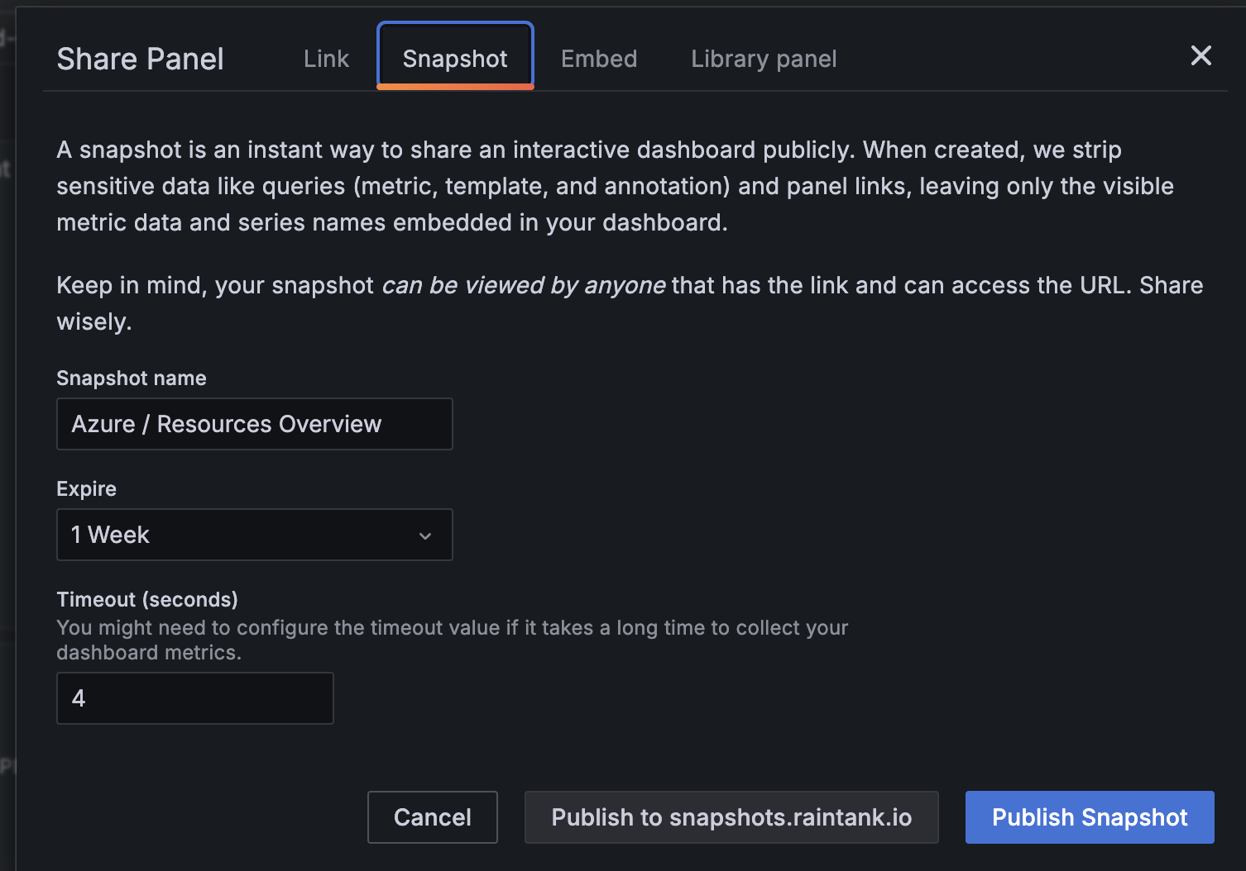

## Embedding

* You can embed a panel using an iframe on another web site.
* A viewer must be signed into Grafana to view the graph.
* Prerequisite properties to be in grafana.ini configuration yaml:

1. auth.anonymous
   * 1. enable: true
     2. org_name: <Org name for which you are granting access>
     3. org_role: <Role>
     4. device_limit: <limit number of devices>
2. security
   * 1. allow_embedding: true
     2. cookie_samesite: none
     3. cookie_secure: true

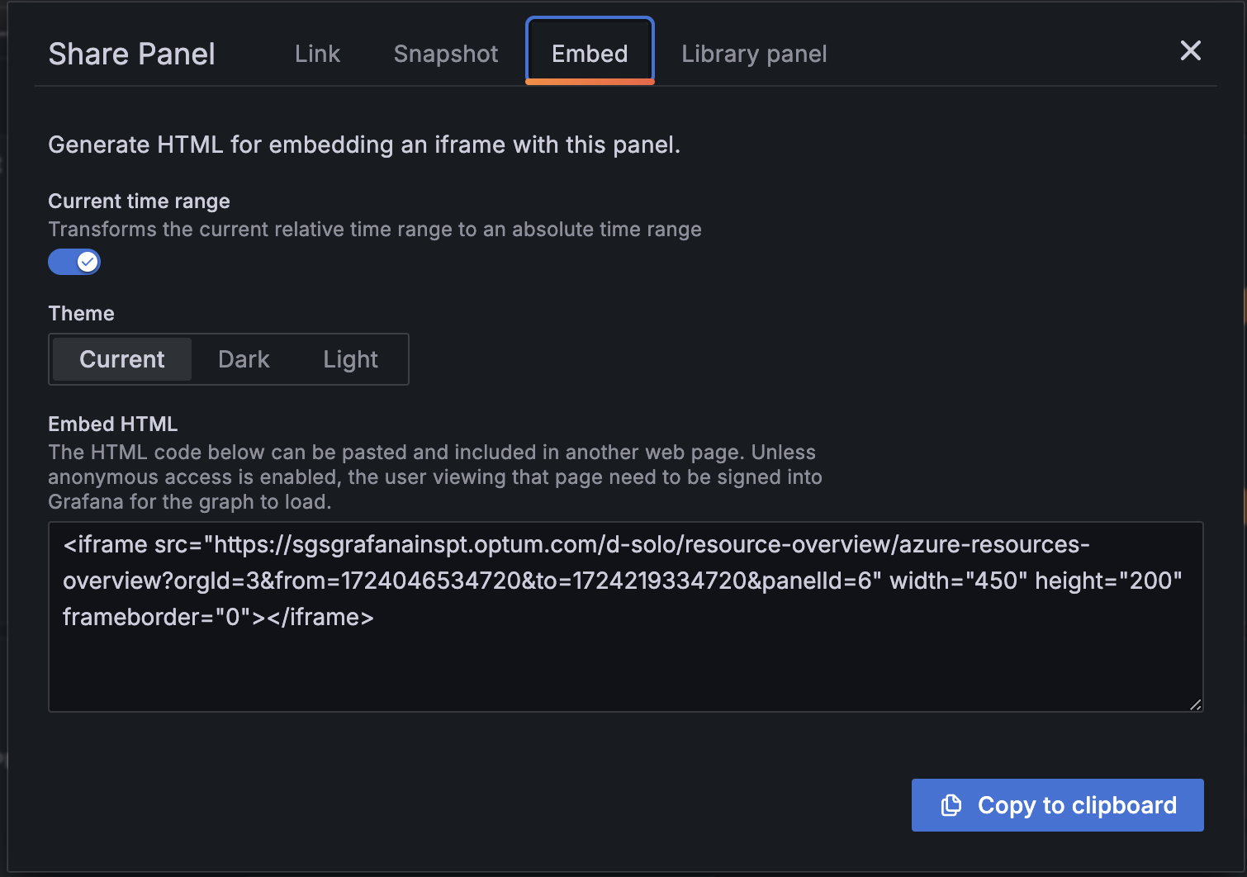

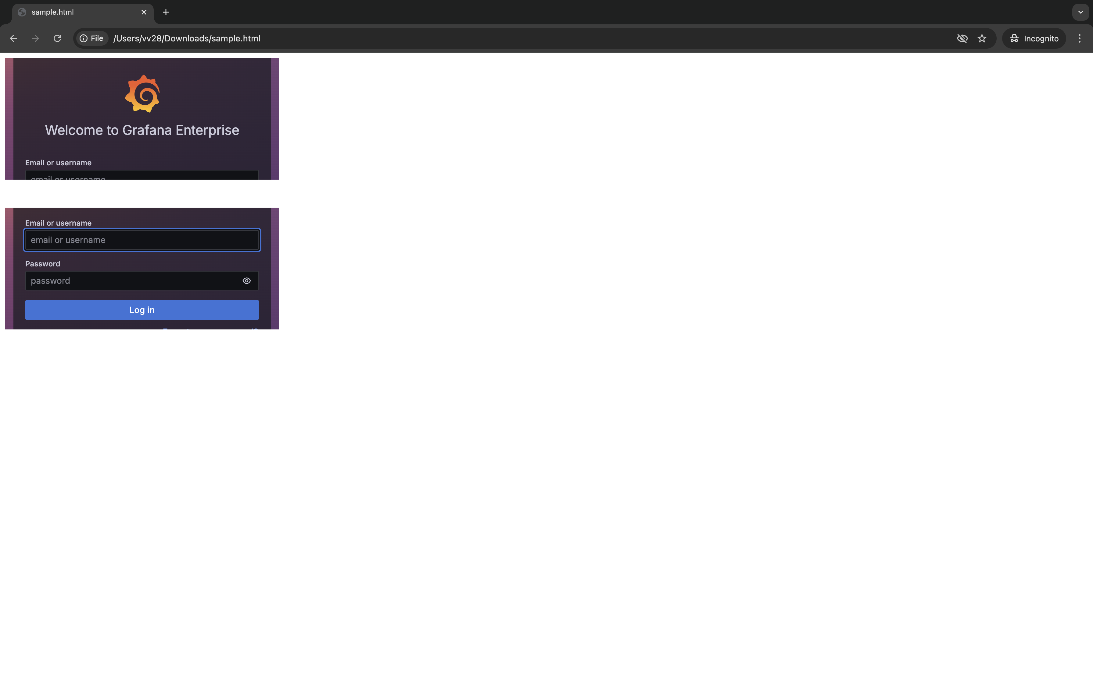

## Comparison

|  |  |  |  |
| --- | --- | --- | --- |
|  | Direct Link | Snapshot | Embedding |
| Access | Any User with the link | Anyone with the link | Users only |
| Login required? | Yes | No | Yes |
| Real Time Data | Yes | No | No |
|  |  |  |  |

## Related Documents

Table 1‑1: Related Documents

| Document Name | Document Location |
| --- | --- |
| Share Dashboards and Panels | https://grafana.com/docs/grafana/latest/dashboards/share-dashboards-panels/#share-dashboards-and-panels |
| Grafana Image Renderer plugin | https://grafana.com/grafana/plugins/grafana-image-renderer/ |
| Grafana CLI (Not preferable approach) | https://grafana.com/docs/grafana/latest/cli/#remove-one-plugin |
| Grafana Image renderer | https://urldefense.com/v3/__https://github.com/grafana/helm-charts/blob/79a0101296b0065b18987321b3047b8c94bc1a33/charts/grafana/values.yaml*L1150C1-L1150C5__;Iw!!IqUcNYopQPk7!KqGZkblAjnkZLr4irMmOrfqj6IvXbdReSFlbhoqvgTGE0-IeIbpMgOb7HjrXJFuLRCNUWMJ3caK7rt1O$ |

Appendix A – Links

| Reference | Links |
| --- | --- |
|  |  |